
Low Level Design Document
Document Release Date: 3rd Jan, 2011


License Agreement

CAREFULLY READ THE FOLLOWING TERMS AND CONDITIONS HAVE THIS AGREEMENT. BY INSTALLING AND USING THE ELITECORE TECHNOLOGIES LTD.SOFTWARE, YOU INDICATE THE ACCEPTANCE OF THE FOLLOWING TERMS AND CONDITIONS AND YOU AGREE TO BE BOUND BY THEM. IF YOU DO NOT AGREE TO BE BOUND BY THESE TERMS AND CONDITIONS, DO NOT INSTALL OR USE THE ELITECORE SOFTWARE AND PROMPTLY RETURN THE COMPLETE PACKAGE INCLUDING THE SOFTWARE TO ELITECORE.

THIS LICENSE AGREEMENT CONSTITUTES THE COMPLETE AND EXCLUSIVE STATEMENT OF THE AGREEMENT BETWEEN YOU AND ELITECORE WITH AND SUPERSEDES ANY PROPOSAL OR PRIOR AGREEMENT, ORAL OR WRITTEN, AND ANY OTHER COMMUNICATIONS RELATING TO THIS AGREEMENT.

Customer hereby agrees and acknowledges that during installation and use the Licensed Programs may access Customer's confidential and proprietary information and/or interface with certain of Customer's databases and Customer hereby consents to such access and/or interface.
Intellectual Property Rights. Customer acknowledges and agrees that the Licensed Programs constitute confidential and proprietary information of Elitecore Customer further acknowledges that all right, title, and interest in and to the Licensed Programs, including associated intellectual property rights, are and shall remain with Elitecore Technologies Ltd. and its licensors. Customer agrees to maintain the confidentiality of the Licensed Programs. Customer shall not, and shall cause its employees and agents not to, disclose or transfer the Licensed Programs to any third party. Customer agrees not to translate, decompile, reverse engineer, disassemble, modify, reproduce, rent, lease, lend, encumber, distribute, remarket, or otherwise dispose of the Licensed Programs or any part thereof. Customer agrees not to duplicate the Licensed Programs, except as required for Customer's use at the Authorized Site in accordance with this Agreement.

Furthermore, Customer acknowledges and agrees that the access granted to Support Providers to Customer's computer systems, files and associated data is merely to facilitate support on Customer's behalf, and Customer remains solely responsible for backing up its systems, files and data.

TO THE EXTENT ALLOWED BY APPLICABLE LAW, THE SUPPORT PROVIDERS SHALL NOT BE LIABLE TO CUSTOMER, REGARDLESS OF THE CAUSE OF ACTION, INCLUDING THE SUPPORT PROVIDERS' OWN NEGLIGENCE, FOR ANY DIRECT OR INDIRECT DAMAGES, INCLUDING WITHOUT LIMITATION ANY LOSS OF DATA OR LOSS OF USE OF COMPUTER SYSTEMS, DUE TO THE SUPPORT PROVIDER'S SUPPORT ACTIVITIES OR THEIR USE OF THE LICENSED PROGRAMS' DIAGNOSTIC FUNCTIONALITY.

Taxes. Customer agrees to be responsible for any and all taxes, duties, tariffs, or other such assessments of any value relating to this Agreement.

Miscellaneous. The terms of this Agreement may be amended, waived, or modified by Customer only in a writing signed by both parties. Customer may not assign or otherwise transfer any of its rights or delegate any of its duties under this Agreement without Elitecore prior written consent.

©Copyright 2000-2001. All Rights Reserved

Document Revision Details
Sr. No. | Version | Release Date | Author | Description
 | 1.0 | 03-01-2011 | Dhaval Nanavati | First Draft

Document Acceptance Certificate
Title: Low Level Design Document

Name | Title | Company | Signature | Date

Table of Contents

Document Revision Details 3
Document Acceptance Certificate 4
1. Project Scope 6
1.1. Purpose 6
1.2. Assumptions 6
1.3. Pre-requisites 7
2. Abbreviations 8
3. Netvertex Solution for PCRF Standards 9
3.1. SoW Highlights 9
3.2. Modules 10
3.3. Interfaces 11
3.4. Interface Approach 12
3.5. Policy Object Architecture 13
3.6. Netvertex Architecture 14

Project Scope

Purpose
This document contains the low-level design architecture and Netvertex deployment & Integration philosophy for the requirement as per PCRF standards. The document covers the following modules:

- PCRF Modules
- PCRF Interfaces
- Netvertex Architecture

Document covers the scope of work for Netvertex system in integration with various network elements to provide complete solution.

Assumptions

- Development based on current experience of different IOTs.
- Currently we supports only RADIUS, DIAMETER and SCE based device.

Pre-requisites
- RADIUS and DIAMETER Modules of EliteAAA. We are reusing these modules.
- SCE Knowledge

Abbreviations

Name | Description
RADIUS | Remote Authentication Dial In User Service
AAA | Authentication Authorization and Accounting
PCRF | Policy Charging and Rule Function
BOD | Bandwidth On Demand

Netvertex Solution for PCRF Standards

SoW Highlights

- Netvertex needs to support RADIUS, DIAMETER or any third party APIs to integrate with the devices.
- Netvertex also needs to support integration with multiple devices at a same time.
- Netvertex works as central policy repository and stores each policy’s definition in proprietary format.
- Netvertex also supports CLI based server architecture to start / stop particular services.
- Netvertex also have a powerful GUI support for admin to configure policy / device.
- Currently we are limited the scope to Policy Manager only which includes Policy Management, Device Management, Bandwidth On Demand. Quota manager will be part of next phase.

Modules

Netvertex has mainly 2 modules.

- GLOBAL LISTENER
This listener will run as service and always ready to listens events from BRAS or some third party system using web service. System will run only one listener to listens the all events.

  - RADIUS
Any BRAS can sends the Radius events to Global listener and global listener will identify the event and next action for the same.

  - WEB SERVICE
Any third party system / SSP can send events to global listener.

- STATE FULL LISTENERS

State full listeners are per device basis. On service start up, it will identify the state full devices in the repository and binds the listener device wise. Means if Netvertex has 8 state full devices, Netvertex runs 8 listeners.

  - SCE
On service startup, Netvertex identifies all SCEs in the repository and binds separate listeners on proprietary APIs.

  - Gx Devices
On service startup, Netvertex identifies all Gx based devices in the repository and binds separate listeners for all on diameter protocols on TCP connections.

Interfaces
System has mainly 3 interfaces.

- RADIUS Interface
Radius interface enables Netvertex to talk with any radius supported device like BRAS. Using this interface; without AAA, Netvertex also can supports BOD request and understands all Radius request.
- Diameter ( Gx Interface )

Gx interface enables Netvertex to talk with any Gx supported device for BOD.

- Custom APIs (SCE)

Currently this interface includes APIs which is related to CISCO SCE 8000.

Interface Approach
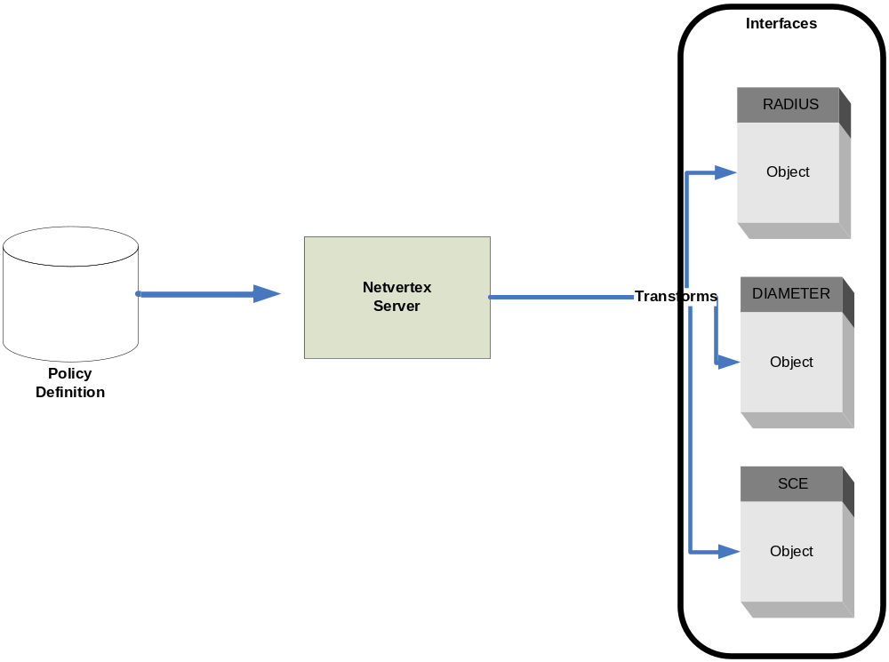

- Netvertex stores Policy definition in the property structure and converts in the required forms when ever needed using the appropriate interface.
- Netvertex needs to implements each drivers and drivers is responsible to convert central policy object to device specific object.

Policy Object Architecture

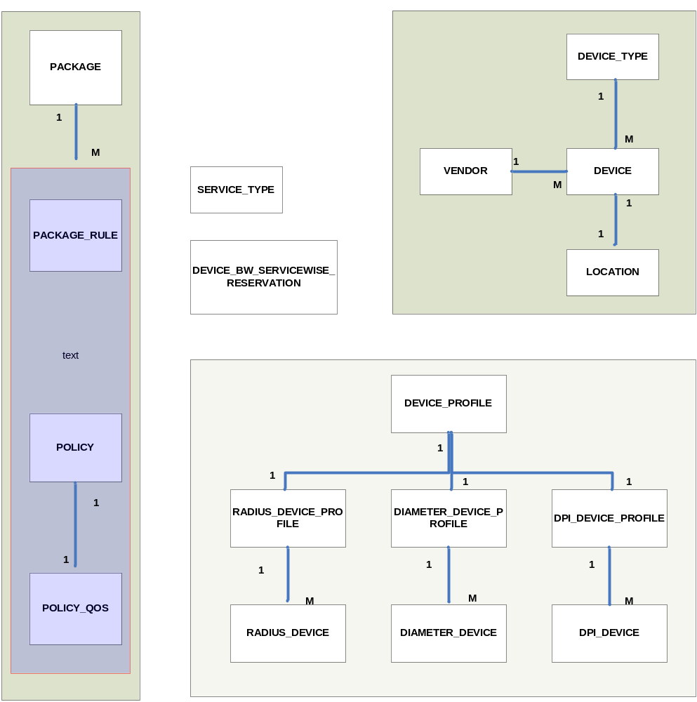

Netvertex Architecture

